(Approx. 290 words)

React 7-In-1 Vehicle Emergency Multi-Tool
by George Harding, Treasurer, Tucson Computer Society
Tucson Computer Society
www.aztcs.org
actuary110 (at) yahoo.com

Here’s a handy gadget! It’s multipurpose and has seven uses.

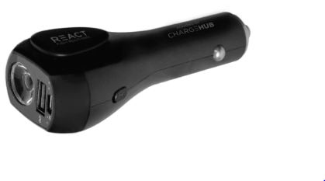

- It can be used in your car to charge any USB chargeable device. You plug it into your car’s power outlet. The enclosed battery will charge if needed and any of our additional devices that you connect to it will charge as well. There is a battery charge indicator to tell you how much charge is available.
- It can be used away from your car as a charger for any USB chargeable device
- It is a flashlight. A button on the side of the React turns on the light. Further presses cycle through low and high options. A long press turns it off.
- Using the side button also gives you access to a red flashing light.
- A button on the other side of the React turns on the S.O.S alarm.
- React includes a seat belt cutter, available for emergency use. The blade is protected so it won’t slice your fingers, but it is strong enough to slice a seat belt.
- React can also be used to break window glass in an emergency. It should not be used to break laminated, windshield, or pane glass.

The manufacturer recommends that the tool be replaced after using either the glass breaker or the seat belt cutter.

The tool comes with a cable that can be used for charging the internal battery. The unit also comes with a User Manual.

The unit has a one-year limited warranty.

This is a very handy tool to keep in your car for use when needed.

React by LimitlessInnovations
Price $40

https://limitlessinnovations.com/collections/usb-chargers/products/react-7-in-1-vehicle-emergency-multi-tool-powered-by-chargehub

